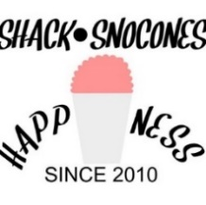
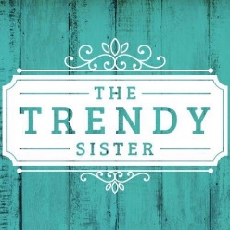
Current Shop 373
Participating Businesses (& their offered Rewards)
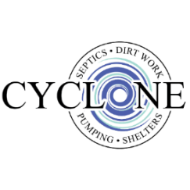
- Pam’s Creations LLC: $2 off a dozen cookies
- Locavores Fork Farm: free lip balm w/ purchase
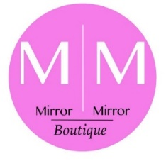
- Mugwamps Fitness: 5 free classes
- Yummy Mondays food trucks at Stone’s
- Cyclone Shelters & Septics: 10% off a service
- Be Here Now Yoga: 10% off any package
- Independent Scentsy Consultant Heather Waller
- Scissortail Photography: Complimentary Session & 10% off your order
- Trendy Sister
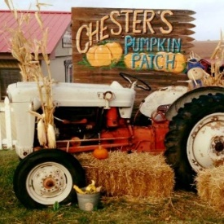
- Cutter Chaos: 10% off any order
- Mirror Mirror Boutique: 10% off purchase
- The Wild Daisy: 15% off one item
- Urban Station Salon: 25% off gift certificates
- DCX Gymnastics: $15 off enrollment fee The Shack SnoCones: 10% off a purchase
- The Old Store: 10% off one item
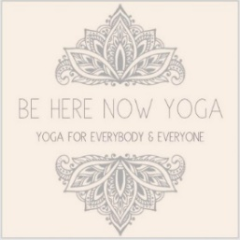
- Chester’s Party Barn: $25 off one birthday party
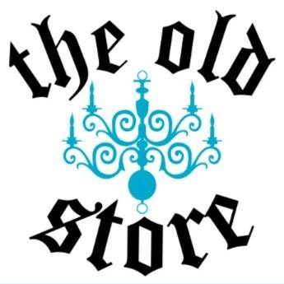
- The Wild Rose: 10% off a purchase
- Owens Roofing: free t-shirt
- Darren Owens Insurance: free stress ball
- Independent Scentsy Consultant Jana Holcomb
- Urban Bee & Soap Company

