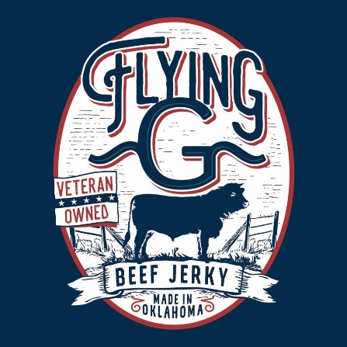
Current Shop 373
Participating Businesses (& Their Offered Rewards)
The Shack SnoCones: 10% off a purchase
The Old Store: 10% off one item
Chester’s Party Barn: $25 off one birthday party
The Wild Rose: 10% off a purchase
Owens Roofing: free t-shirt
Darren Owens Insurance: free stress ball
Independent Scentsy Consultant Jana Holcomb: 640-4233
Urban Bee & Soap Company: 620-6999
Pam’s Creations LLC: $2 off a dozen cookies
Cyclone Shelters & Septics: 10% off a service
Be Here Now Yoga: 10% off any package
Independent Scentsy Consultant Heather Waller: 514-9248
Scissortail Photography: Complimentary Session & 10% off your order
Trendy Sister: 249-6380
Cutter Chaos: 10% off any order
Flying G Jerky
