June at the Library! | 2021
Sunday | Monday | Tuesday | Wednesday | Thursday | Friday | Saturday
 |  | 1 | 2 | 3 | 4 | 5
Theme:  Farmyard Friends  (Pageturner Adventures online) |  | Fire Dept 11-Noon;  Pick up Reading Log & Craft Bag-to-Go |  | Family Game Time 3pm-5pm
6 | 7 | 8 | 9 | 10 | 11 | 12
Fish Tales |  | Inspyral Circus 11-Noon; Pick up Craft Bag-to-Go |  | Family Game Time  3pm-5pm |  | Garden Club 11am
13 | 14 | 15 | 16 | 17 | 18 | 19
Pet Pals | Alex Thomas Caricature Tutorial  (Virtual access) | Piedmont Police Dept 11-Noon;  Craft Bag-to-Go
20 | 21 | 22 | 23 | 24 | 25 | 26
Celebrity Critters |  | Hooplahoma 11-Noon; Craft Bag-to-Go
27 | 28 | 29 | 30
Safari Stories
SO Much to do!! | 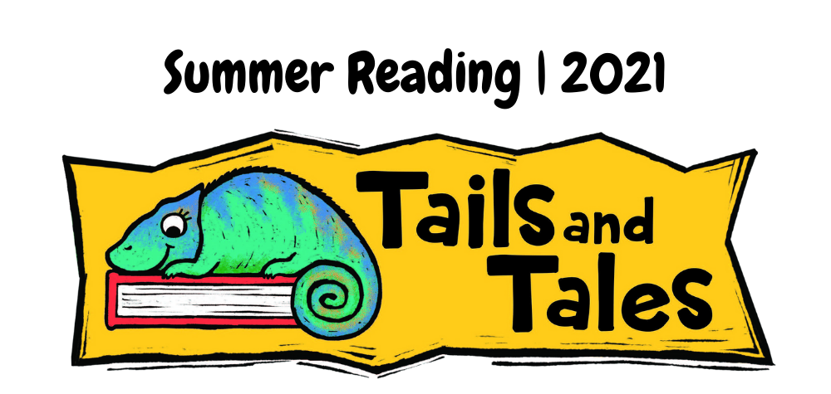  Heading  To get started right away, just click any placeholder text (such as this) and start typing to replace it with your own. | The WORKS  We’ve got a little Virtual, a little Live-and-in-Person, a lot of reading, and a ton of fun in store this month! | Reading Logs  Don’t forget to pick up your Reading Log – 20 minutes a day for 7 days gets you a prize from our summer reading STORE!! Woot!
Call with Questions: 373-9018

